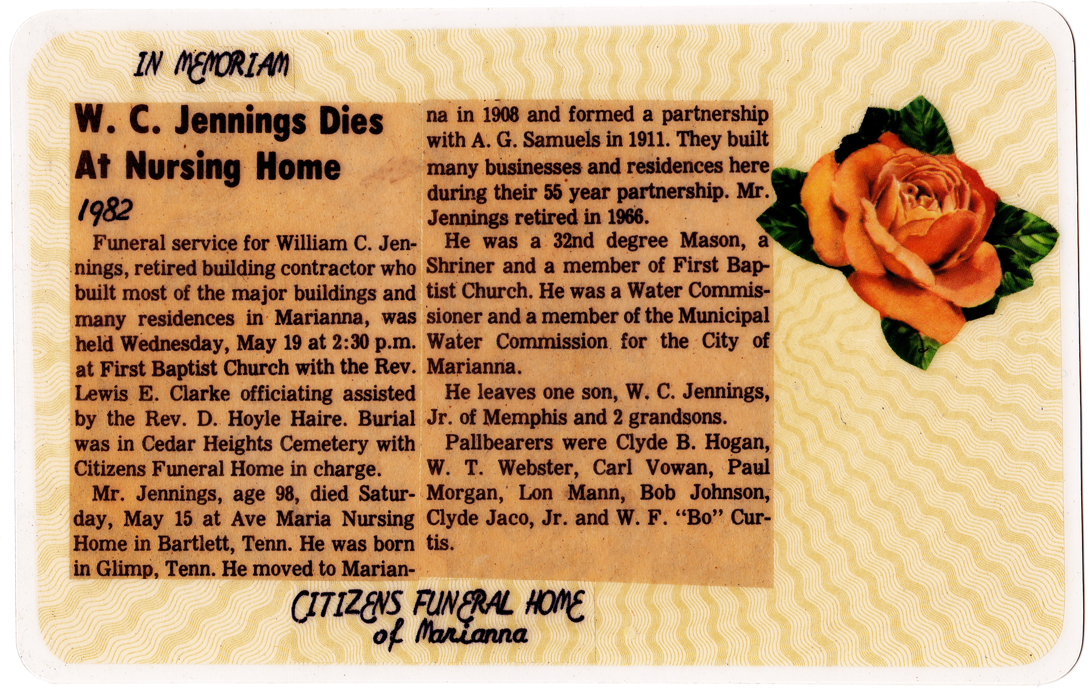

In Memoriam
W.C. Jennings Dies At Nursing Home
1982

Funeral service for William C. Jennings, retired building contractor who built most of the major buildings and many residences in Marianna, was held Wednesday, May 19 at 2:30 p.m. at First Baptist Church with the Rev. Lewis E. Clarke officiating assisted by the Rev. D. Hoyle Haire. Burial was in Cedar Heights Cemetery with Citizens Funeral Home in charge.

Mr. Jennings, age 98, died Saturday, May 15 at Ave Maria Nursing Home in Bartlett, Tenn. He was born in Glimp, Tenn. He moved to Marianna in 1908 and formed a partnership with A.G. Samuels in 1911. They built many businesses and residences here during their 55 year partnership. Mr. Jennings retired in 1966.

He was a 32nd degree Mason, a Shriner and a member of First Baptist Church. He was a Water Commissioner and a member of the Municipal Water Commission for the City of Marianna.

He leaves one son, W. C. Jennings, Jr. of Memphis and 2 grandsons.

Pallbearers were Clyde B. Hogan, W. T. Webster, Carl Vowan, Paul Morgan, Lon Mann, Bob Johnson, Clyde Jaco, Jr. and W. F. “Bo” Curtis.

Citizens Funeral Home of Marianna

